

“I would like to extend my sincere felicitations to Canadian Tamil Youth Alliance organizers of Thaalam 2014.

Performing arts completion like Thaalam is an effective way to inform our youth and others about our culture and heritage. It provides competitors a stage to showcase their talents and for the audience enjoying spectacular performances and greats works of arts literature and poetry.

Our strength lies in diversity. We are a proud collections of different ancestries, languages and beliefs. We enjoy different cuisines and play various sports. Our rich heritage, strong family, social ties and successful businesses with hard working Ontarians have helped create the prosperous and dynamic society we enjoy today

I would also like to congratulate all competitors and volunteers who help make this festival a success. My message to all the teams competing is to work hard and enjoy
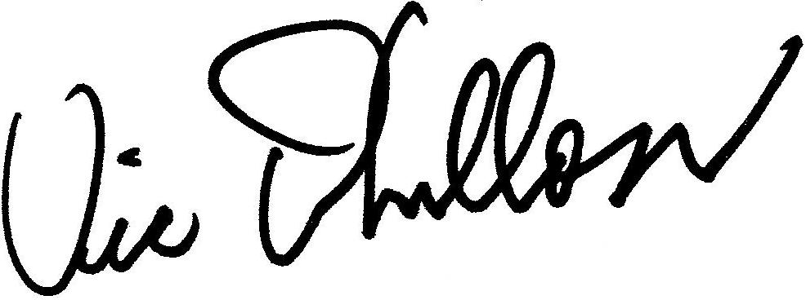
Best Regards,

Vic Dhillon MPP Brampton West

