March 22, 2014

To the Members of the Canadian Tamil Youth Alliance:

As the Member of Provincial Parliament for Newmarket-Aurora, I extend greetings and best wishes to the participants in the Thaalam 2014: The Ultimate Gaana Competition.

I take this opportunity to acknowledge the ongoing work of the Canadian Tamil Youth Alliance for all that you do to develop and strengthen the youth of the Tamil community to proudly make their place in the Canadian Mosaic.

Please accept my best wishes for what I know will be a successful and memorable day!

Sincerely,
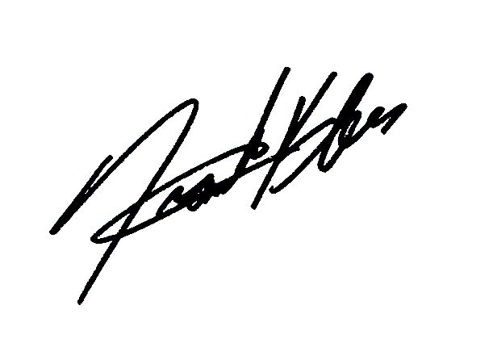
Frank Klees, M.P.P.
Newmarket-Aurora

